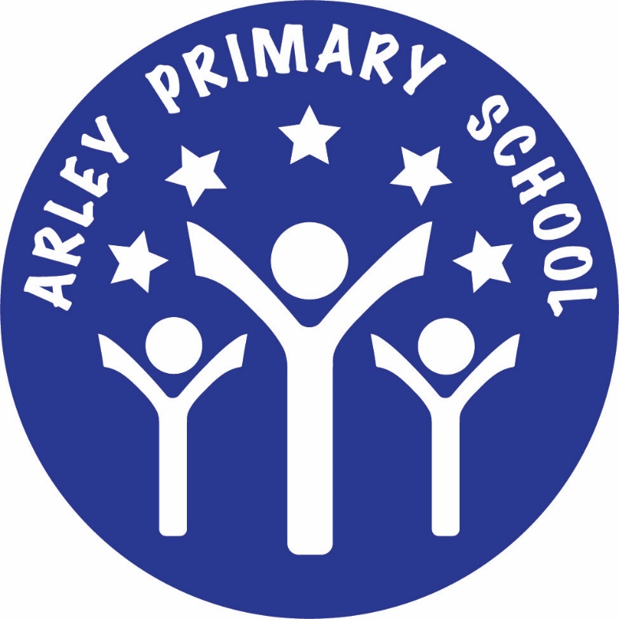

Continuity of Learning Policy
Our vision for remote and blended learning

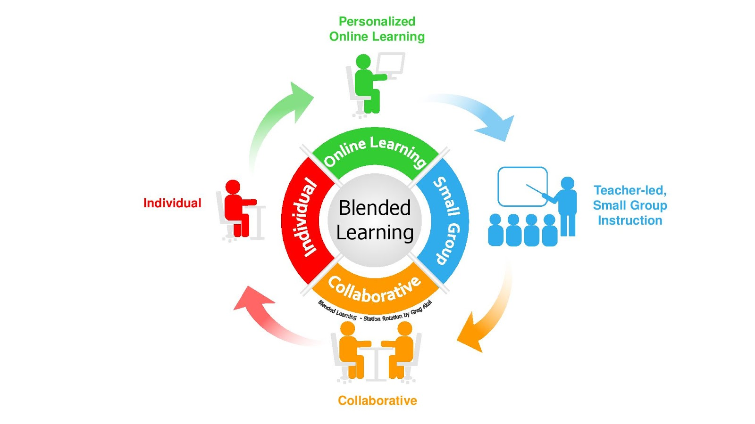

1. INTRODUCTION AND AIMS
In September 2020 all of our classes returned to full time education following the COVID-19 national lockdown in March 2020. Although we hope that the majority of our children will now have an uninterrupted experience, there is the possibility that an individual child, a class bubble, or indeed the whole school, will need to self-isolate for a period of time. We have therefore put in place a plan for remote learning so that children can continue with their education.
This Continuation of Learning Policy has been written as guidance for staff and parents following the experience of a period of national lockdown when all schools were providing remote learning to their pupils and as a response to parent/pupil surveys during the first lockdown period.
The policy sets out the systems and technology that staff will use to keep the learning experience going for children, and details how they can be used effectively and safely, while allowing for the differing needs of families, whilst continuing to focus on our identified four elements that work in concert to create the most powerful deep learning experiences and considering staff workload.
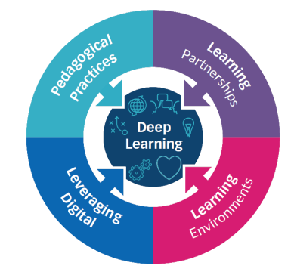

The school’s Online Safety Policy and Acceptable Use Agreements still apply at this time.
The strategy outlined below is predicated on:
● A largely asynchronous approach to teaching and learning, maintaining our pedagogical principles.
● Using existing tools with which staff are likely to be familiar to leverage digital, provide a suitable online learning environment and provide learning partnership opportunities.
● Reducing the reliance on high-bandwidth, stable internet connections which may not necessarily be available.

2. DEPARTMENT FOR EDUCATION REMOTE LEARNING EXPECTATIONS
Where a class, group or a small number of pupils need to self-isolate, or local restrictions require pupils to remain at home, the Department for Education (DfE) expect schools to have the capacity to offer immediate remote education. Schools should ensure remote education, where needed, is high-quality and aligns as closely as possible with in-school provision.
The Secretary of State for Education has issued a continuity direction that requires schools to provide remote education for state-funded, school-age children unable to attend school due to coronavirus (COVID-19). We have published guidance that explains the purpose of the various provisions within the Coronavirus Act 2020 Provision of Remote Education (England) Temporary Continuity Direction.
Schools are expected to consider how to continue to improve the quality of their existing curriculum, for example through technology, and have a strong contingency plan in place for remote education.
When teaching pupils remotely, The DfE expect schools to:
● Set assignments so that pupils have meaningful and ambitious work each day in a number of different subjects.
● Teach a planned and well-sequenced curriculum so that knowledge and skills are built incrementally, with a good level of clarity about what is intended to be taught and practised in each subject.
● Provide frequent, clear explanations of new content, delivered by a teacher in the school or through high-quality curriculum resources or videos.
● Gauge how well pupils are progressing through the curriculum, using questions and other suitable tasks and set a clear expectation on how regularly teachers will check work.
● Enable teachers to adjust the pace or difficulty of what is being taught in response to questions or assessments, including, where necessary, revising material or simplifying explanations to ensure pupils’ understanding.
● Plan a programme that is of equivalent length to the core teaching pupils would receive in school, ideally including daily contact with teachers.
3. A FLEXIBLE APPROACH
We understand that everyone’s circumstances at home will be different. Some families have one child to support while others have several. Some families have one device to share while others may have more - and some things may work differently on different devices. Some parents will have plenty of time to help their children learn, while others will be working from home and may have much less time and some children will be able to work more independently than others or need greater challenge.
Due to this we are providing a flexible approach to remote learning. We will not be providing a full school day of live lessons as this will be unmanageable for the majority of families - not to mention keeping children at a screen for far too long. We will offer a variety of daily online and offline learning activities across the curriculum so that pupils can work their way through things as and when they are able.
Right from the start of lockdown in March 2020 we decided we would not be teaching live lessons. Here are the considerations why:
1. Some families do not have enough devices for every child and enough bandwidth/data package to access live lessons at the same time.
2. Some parents are working from home or looking after babies/very young children and are unable to support their child with learning at specific times of the day.
3. Some teachers are having to juggle looking after their own children and supporting their learning from home so they cannot spend 5 hours locked away in a study broadcasting lessons.
4. Some of our pupils will also have been given childcare responsibilities to enable their parents to work from home.
5. There are considerable safeguarding concerns around live lessons.
6. For teachers, parents and children it becomes very impractical if lessons are streamed live.
The alternative, prepared materials (e.g. worksheets, video clips, slides with video narration) have the advantage that they can be set at any time and completed at any time.
Everyone can work around shared technology. They also need less data to download and access than streaming will.
7. The delivery of ‘live’ lessons using video conferencing is extremely difficult and time consuming, and can have a low impact. It’s also not realistic for the school to expect to replicate the breadth or pace of our face-to-face curriculum.
It does feel intuitive that we would want to best replicate the experience of being in the classroom and that live lessons online would be the closest to this. The problem is, it doesn’t take into account all the ways that online lessons will differ from those in the classroom. Super teachers create electricity in their classroom, which is much harder to achieve online. The greatest barrier is feedback and social exchange: the delicate task of providing feedback relies on relationships, context, tone, facial expressions, body language, scanning the room - virtually impossible in an online classroom.

4. THE RESEARCH
The Education Endowment Foundation (EEF) published a rapid evidence assessment on Remote
Learning in April 2020. In summary, the findings were:
● Teaching quality is more important than how lessons are delivered: pupils can learn through remote teaching but what matters most is ensuring the elements of effective teaching are present, e.g. clear explanations, scaffolding and feedback - is more important than how or when they are provided. There was no clear difference between teaching in real time (“synchronous teaching”) and alternatives (“asynchronous teaching”).
● Ensuring access to technology is key, particularly for disadvantaged pupils: almost all remote learning uses digital technology, typically requiring access to both computers and the internet. The lack of technology is a major barrier to successful remote instruction, not only for pupils but also for staff.
● Peer interactions can provide motivation and improve learning outcomes: peer interaction during remote learning is important as a way to motivate pupils and improve outcomes, including peer marking and feedback, sharing models of good work, and opportunities for live discussions of content.
● Supporting pupils to work independently can improve learning outcomes: pupils learning at home will often need to work independently so teachers prompting pupils to reflect metacognitively (plan, monitor, evaluate) on their work, providing checklists or to consider the strategies they will use if they get stuck is valuable.
● Different approaches to remote learning suit different tasks and types of content: approaches to remote learning vary widely and have different strengths and weaknesses, dependent on the content they are teaching and the age of their pupils, e.g. games for learning, retrieval practice and self-quizzing.

5. ROLES AND RESPONSIBILITIES
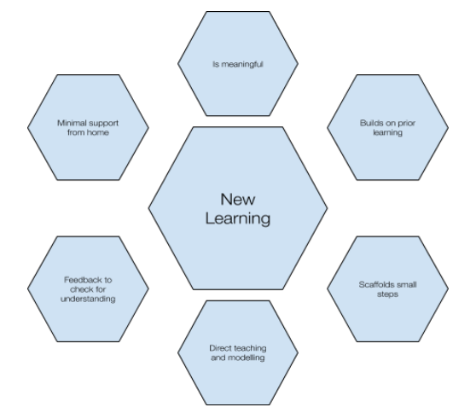

Teachers must be available between 9am and 3pm. If a teacher is unable to work for any reason during this time, for example due to sickness or caring for a dependent, they should report this using the normal procedures. Teachers are responsible for:
● Setting a weekly and daily timetable of sequenced work for their class following on/mirroring the lessons being covered in the classroom at that time, with accompanying videos, slides, worksheets etc.
● Setting work on the usual online homework platforms.
● Questioning, assessing and checking work to determine how well children are progressing through the curriculum.
● Providing feedback to individuals, groups of pupils or the whole class.
● Share WAGOLLS (What A Good One Looks Like) from children as an example to support and encourage others.
● Keeping in touch with pupils and parents.
Teaching Assistants must be available between 9am and 3pm (or their usual part time hours). If a teaching assistant is unable to work for any reason during this time, for example due to sickness or caring for a dependent, they should report this using the normal procedures.
Teaching assistants are responsible for:
● Supporting pupils with learning remotely.
● Providing differentiated support as directed by the SENCO.
● Attending virtual meetings with teachers, parents and pupils.
Senior Leaders are responsible for:
● Co-ordinating the remote learning approach across the school.
● Advising on specific curriculum areas and for groups of pupils with special educational needs.
● Helping to identify children who may need support and/or accessing appropriate resources.
● Monitoring the effectiveness of remote learning.
● Monitoring the security of remote learning systems, including data protection, online safety and safeguarding considerations.
Designated Safeguarding Leads are responsible for:
● Maintaining contact, collating, passing on information and responding to any concerns.

6. CONTINUITY OF LEARNING STRATEGY
We are providing remote learning through a range of sites and services, most of which are part of our usual online provision for children that we have spent years integrating into our practice.
Online learning will complement the paper-based activities sent home with children. There is no expectation that parents need to print out work.

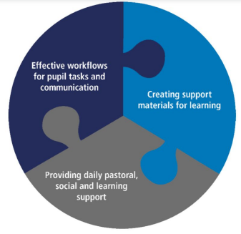

Effective Workflows for Pupil Tasks and Communication
Providing daily guidance, encouragement and activities will be essential in maintaining pupils’ progress during school closures. Having an understood workflow in place for tasks and support materials will become increasingly vital and hard to establish once children are at home. For this reason it is important to create and communicate a digital workflow from the outset. ‘DB Primary’ is our main method of communication between school and families and is used for posting weekly and daily timetables and text, audio, video and photo updates. Families should access this via the school website and check personal email accounts for messages.
Creating Support Materials for Learning
Issuing and completion of tasks alone will be insufficient for most pupils after the first few days and will rapidly become very dull for them - it is necessary that some form of teaching continues, albeit at a distance. Live lessons are difficult to manage and the pedagogy they enforce due to the lack of physical presence is entirely different. For these reasons, a lower-tech, asynchronous approach will be used.
Staff will create videos (where necessary) to support direct instruction teaching input tutorials, combined with a visualiser or presentation software such as PowerPoint to create short voice-over explanations of concepts, methods and subject content.
These benefit from interleaving audio, text and visual content, making use of existing resources in a familiar tool and will be accessible to pupils even if viewed on a parent’s phone. Importantly, children will see the teacher’s face and hear the teacher’s voice explaining things in the same way as usual and they will be able to re-watch as many times as necessary.
Staff will also use materials from Purple Mash to support learning and use videos for reading stories to the class.
Staff will signpost Oak National Academy pre-recorded lessons, which are delivered by a teacher and includes quizzes, worksheets and creative activities.
Google Forms can be used to create quizzes to check for understanding.
Online English Platforms
Differentiated spelling, punctuation and grammar activities with instant computer feedback will be set on DB Primary.
Children in Year 2 - Year 6 who have finished their reading books can read texts from Serial Mash as directed by the class teacher, completing associated tasks online.
Maths Platforms
Differentiated Maths activities with instant computer feedback are assigned and completed through Mymaths.co.uk (Year 1-6), Numbots (Reception - Year 2) and Times Tables Rockstars (Year 2- Year 6.) Apps are available.
Staff will use the White Rose Maths video tutorials and resources.
Any use of online learning tools and systems is in line with privacy and data protection (GDPR) requirements. Staff will not use online tools which have not been approved through the GDPR processes.
Providing Daily Pastoral, Social and Learning Support
If schools remain closed for more than a few days, the need for staff to check in on pupils will grow - from both an academic and pastoral point of view. Online modes of learning can mask things which would be obvious in school, such as whether a pupil is struggling with some aspect of their learning or is socially isolated. School staff are relationship builders and connectors, so a practical response would be to hold short video conferences with small groups or a class of pupils on a regular basis so that teachers and pupils have a space in which to talk about how things are going, to maintain a sense for them of being part of a class. While teaching a primary class this way is not practical, safe, supervised and structured opportunities will be offered for children to ‘meet up’ with their teacher and classmates as a social exchange between teacher and pupil and between peers is an important part of teaching and learning. This will be done using DB Primary and/or MS Teams.
● Communication between staff and children/families must be through the authorised school systems and not through email or personal social media accounts. It should follow the usual rules outlined in the Online Safety Policy, Staff Behaviour Policy (Code of Conduct) and Acceptable Use Agreements.
● An appropriate adult must remain in the same room as the child during video calls to monitor and ensure they are safe and using the technology appropriately.
● Children must take part in the meet up in a suitable communal environment (not in a bedroom) and be appropriately fully dressed. School uniform is not required.
● All members of the household must be aware that the meeting is taking place and make sure they are also suitably dressed and use appropriate language and behaviour when nearby or in the background. Blurred or virtual backgrounds are recommended.
● The teacher must make sure all children have left the call correctly once it is finished - before turning off any devices.
● Screenshots, photos or recordings of video calls must not be made and the link must not be shared with others.
● Due consideration should be given by staff before sharing photo, audio or video as to whether there are any issues regarding reputation, professional conduct, online safety or safeguarding.
● No staff member will contact parents or children on DB Primary or MS Teams outside of any pre-arranged meeting. A teacher and one other staff member will be present throughout planned video calls to help safeguard all participants and monitor appropriate use.
● Staff will ensure appropriate security settings are in place for the meeting, ensuring that access is only granted to the expected registered users.
● We would strongly recommend that staff avoid using personal devices and should only use the school provided equipment.
7. EDUCATIONAL PROVISION
While we understand that remote learning may be easier for some families than others, we no doubt all agree that keeping regular learning going during partial or full closures is of vital importance to reducing further impact on children’s education.
Staff will post daily flexible timetables on DB Primary for their class. This will outline a range of online and offline learning activities in a variety of subject areas and contain tasks and links to follow a coherent curriculum, replicating what would have been taught in class, wherever possible, in any order and a time that suits. We appreciate that some families may not be able to engage with the full timetable.
Opportunities to join in with time-scheduled live events will be highlighted. Assembly links will also be shared.
Throughout the day, further posts on DB Primary will add extra detail, feedback or examples as necessary. Staff will aim to maintain our pedagogical principles in our Teaching, Learning and Curriculum Policy for remote teaching, Making Every Primary Lesson Count six principles to support great teaching and learning, and Rosenshine’s Principles of Instruction.

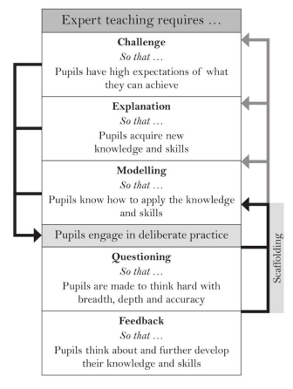

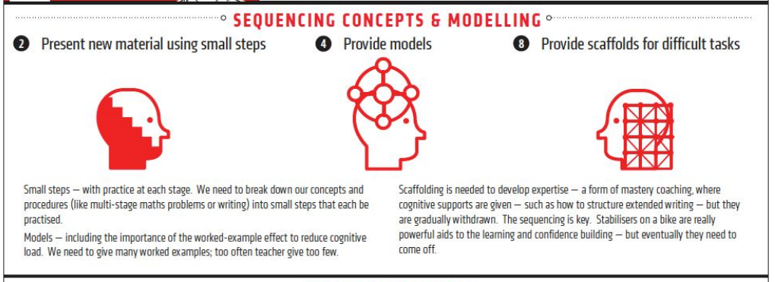
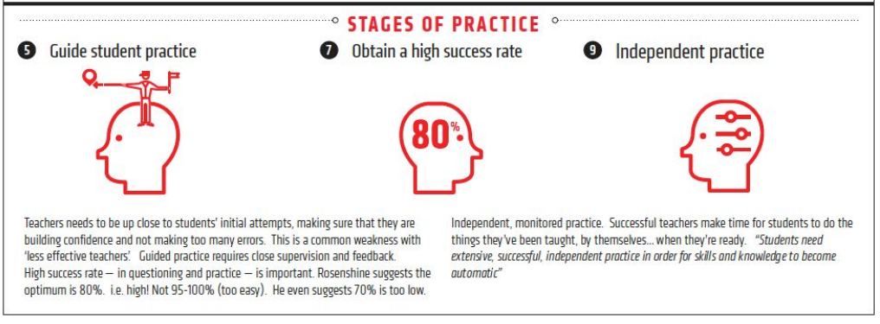
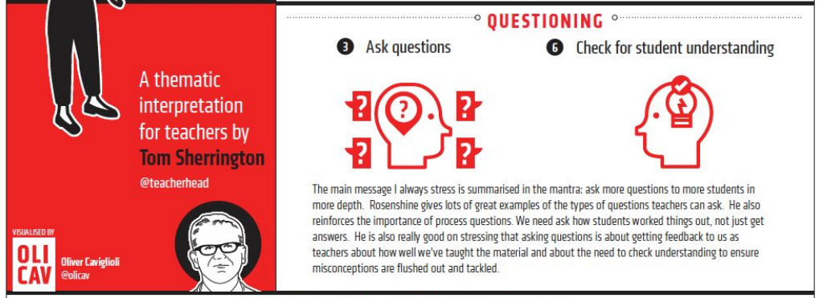
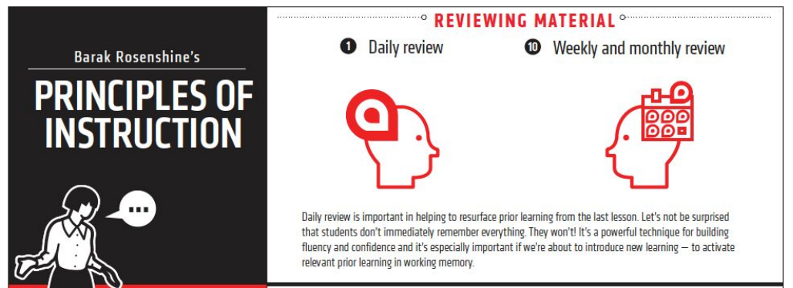

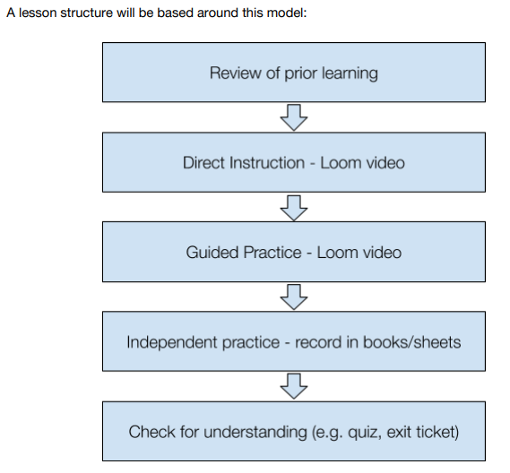

8. PROVISION OF DEVICES
If a child does not have access to a computer/laptop/tablet and/or the internet, the school will do all it can to support children and will provide paper packs of learning. Where funding can be accessed, internet-enabled devices and/or 4G connections will be sought, particularly for disadvantaged children. Parents will be reminded to make the school aware of any barriers to accessing remote learning.
The Department for Education has stated that devices can be ordered for disadvantaged children in years 3 to 11 who are unable to attend school when:
● A primary school is only open to vulnerable children and the children of critical workers.
● A school has 15 or more children in years 3 to 11 who are self-isolating, having each been exposed to a confirmed case outside the school community.
● A local health protection team has advised a group of children in years 3 to 11 (such as a ‘bubble’ or year group) not to attend school.
● A school is fully open but supporting a disadvantaged child living in another area who is unable to attend due to local travel restrictions.

9. OUR REMOTE LEARNING OFFER
Circumstance | Remote Learning
A child (and their siblings if they are also attending the school) is absent because they are awaiting test results and our household is required to self-isolate. The rest of the school bubble are attending school and being taught as normal. | ● Additional work set on Mymaths.co.uk following on/mirroring the maths unit being covered in the classroom at the time.  ● Additional work set on Numbots/Times Tables Rockstars.  ● Additional work set on DB Primary/Purple Mash.  ● Signposted to White Rose Maths home learning videos and accompanying resources following on/mirroring the maths unit being covered in the classroom at the time.  ● Signposted to Oak Academy video lessons and accompanying resources following on/mirroring the topics being covered in the classroom at the time.  ● Paper pack of learning to include English, Maths and Topic work.  ● Phonics/spellings activities.  ● Handwriting practice.  ● Teacher/teaching assistant checking in on DB Primary.
My child’s whole bubble is not permitted to attend school because they, or another member of their bubble, have tested positive for COVID-19. OR We enter another lockdown with total school closure | ● Weekly and daily timetable set on DB Primary outlining offline and online activities to be completed in any order that day,  incorporating videos, paper based work and online platform tasks.  ● Daily Deliberate Practice:  - Total Recall number bonds/times tables.  - Phonics/spelling rules.  - Handwriting.  - SPaG.  ● Daily Lessons:  - Maths.  - English - Book Talk (including time for reading and storytime) or Writing.  - Topic/Computing/Music.  ● PE - signposting activities for exercise at home (e.g. Joe Wicks, Onside Coaching, Wade Gymnastics).  ● Teacher/teaching assistant on DB Primary to provide additional support, audio/video/written feedback, prompts.  ● Weekly video meetings as a whole class or in smaller groups.
PLEASE SEE THE DIPR ON GDPR

