Governors | More about us…
Emma Hunt  (Chair) | I joined as a Co-opted Governor in October last year, and as many of you will already know I am a local self-employed mum and have two children at Arley Primary. I am very proud of our school and want to support the children, parents and staff that all work so hard to make it special. I hope that my business and finance experience can be useful where needed, and will offer my time and knowledge where possible. As with all of our governors I am friendly and approachable and will bridge the gap between parents and school to ensure that we all continue to support each other and to grow and develop together.
Jodie Gosling  (Vice Chair)  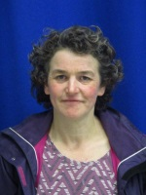 | I have been a governor at Arley Primary since 2013 and before that at Herbert Fowler. I have had three children attend Arley Primary, one who is still in key stage one and two who are now at secondary school. I have been a teacher for nearly 20 years and am passionate that all children should have access to high quality education to provide them with the best chances in life. I love living in Arley and try to support our community through a number of roles such as the Big Local partnership board, the Friends of Daffern Wood group and as Labour Borough Councillor for this area. The role of governor is incredibly important and it is a privilege to work with the wonderful staff, pupil and families and help the school as it continues to strive for excellence.
Linda Kelly  (Headteacher)  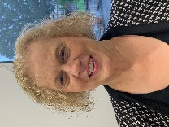 | I consider it a privilege to be the Head teacher of Arley Primary school. I was appointed in September 2019 to lead teaching and learning and to set, along with the range of stakeholders in the school community, the strategic vision for our school. I started my career in January 2000 and have been a teacher, Assistant Head teacher and Deputy Head teacher in a range of schools. I believe teaching is a vocation and as a parent, grandparent and Head teacher take seriously the responsibility of developing our young people to be resilient, independent and happy learners who are ready for the challenges of an ever-changing society. As a leadership team (including both senior staff in school and the Governing body), we work closely together to uphold the vision and values and positively challenge the strategic direction set. We are reflective in our management and decision making and through a relationship based on commitment, dedication and ‘critical friendship’ seek to provide opportunities for excellence and enjoyment for our children.
Sharon Riley  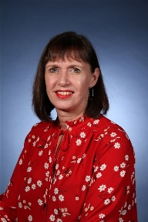 | I am the current Deputy Head Teacher at Arley Primary and I joined the school in September 2012 – during the exciting move to the new building to Gun Hill, New Arley. My role within the Governing Body is very much about keeping Governors up-to-date with current trends and practices in Assessment; ensuring that all Governors are able to articulate how we assess at Arley Primary. I am responsible for providing the Governors with up-to-date data headlines; the impact of interventions; vulnerable groups and next steps for the school. I also teach in the class for 0.5 of the time; so I am very aware of the day-to-day practices at Arley. My role as a Deputy Head Teacher is to support the ideals and policies of the Head Teacher and the school. I firmly believe that all children should have the opportunity to excel in all aspects of Arley Primary School life; developing themselves into independent young people ready for the world beyond Primary School.
Sandra Piper  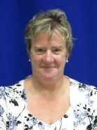 | I am a Parent Governor at Arley Primary School. I have one child in Key Stage 2, and have two other children that have passed through the school via Gun Hill Infants and Herbert Fowler Junior and then the newly amalgamated school. I became a governor because I wanted to gain a deeper understanding of the education system. I am now more aware of the many problems facing the teaching staff, which you do not always get to appreciate as a parent. I really love to work with the children as a parent helper, as I get to see, first- hand, how the children interact with each other, how proud they are of their school and the high quality work that they produce.
Eric Fellows  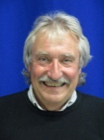 | I have lived in Old Arley for over 30 years, moving here originally from Marston Green. I am a Parish Councillor for Old Arley, a board member on the Big Local committee and President of the Arley Branch of the Royal British Legion. I am also a member of the Parochial Church Council for the Parish of The Whitacres, Lea Marston and Shustoke.  I trained as an engineer, and have been running my own business for thirty five years and feel that some of the experience gained over this time will enable me to help the school move forward with confidence.
Hilary Power  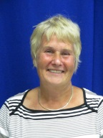 | I am now retired, having been in teaching for over 33 years. Although I taught across the primary age range , the majority of my career was at Gun Hill Infant School, where I was Deputy Head and on several occasions Acting Head Teacher. I also served on the Governing Body of both Herbert Fowler Junior School and Gun Hill Infant School for approximately 20 years, before the amalgamation of the two schools and the formation of the new governing body of Arley Primary School. All children are entitled to the best education possible in order achieve their goals in life, as a governor of Arley Primary School I believe that it is my role to support the school in delivering this aim.
John Elmer  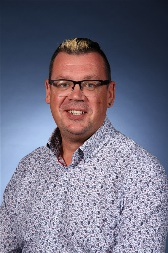 | I have been a teacher at Arley Primary School since it opened in 2013 and previously worked at Herbert Fowler Junior School (one of the 2 amalgamated schools) for 10 years before that. I currently hold the position of Key Stage 2 leader, Maths Co-ordinator, MFL Co-ordinator and a member of the SLT. I am a co-opted governor and my responsibilities include ensuring governors have access to appropriate training in order to keep up-to-date in all areas of school governance.
Leanne Critchlow  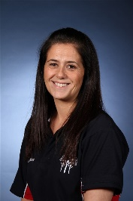 | I have been a teacher at Arley Primary School since September 2015 and previously worked at Bournebrook C of E Primary School for 12 years before that. I currently hold the position of Key Stage 1 leader, Literacy Co-ordinator and am a member of the SLT. I am a co-opted governor because I have a passion for education and the future of all pupils at Arley Primary School.
Janice Steane  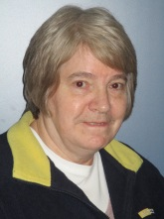 | I’ve been a Governor at the school for just over a year and formerly served for 3 years on the Governing Body of the Infant School. I retired from my job as a Business Manager in a Coventry primary school in 2015, after 20 years! During that time I saw many changes in primary education and these are ongoing. I wish to support the staff and the children to achieve their potential and enjoy learning. I have recently started to come in to school to listen to readers. Being able to read and understand is so important and the key to opening up all forms of learning.
Lexie Gardner  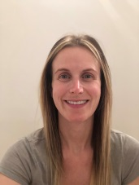 | I joined as a Parent Governor in the summer of 2018 and my role within the Governing body is to lead and oversee ‘Friends of Arley.’ I am delighted to have this role, as I have a wealth of experience and contacts to draw on resources, which would directly benefit the children by increasing the fun and memorable experiences available to them. My role will allow me to influence in areas that matter to myself, parents and carers alike, not to mention our children. Alongside the staff, no one is more concerned with the quality of the teaching and learning provision of the school. Having your child’s best interests at heart means that you'll also have the school’s best interests at heart, which makes you committed to the school’s continuous improvement for the benefit of your child. With 3 of my 4 children currently attending Arley, I hope my time and support will only continue to see the great progress and headway this school is making.
Gary Green | I am a local man, having lived in Old Arley for nearly thirty years. I have been the Chairperson of the Parish council. I have a keen interest in the education system having benefited from it as a child. Education enabled me to start on my career path. I am proud to have a strong connection with the Scout Association. This was the key to my development as a teenager. I would like to be a proactive member of the FGB at Arley Primary School and use my business experience to support the school as it moves forward.
Andrea Wilkinson  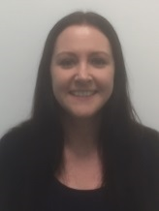 | My love of learning has driven me all my life and I know how important it is that we value education above all else. After completing GCSE’s and A-levels I went to the University of Sussex and got a 1st class degree in Applied Psychology and then went on to study Medicine at the University of Leicester. I have worked as a Doctor at George Eliot Hospital and University Hospitals, Coventry for the last eight years and part of my current role is to train medical students to become doctors by giving tutorials, lectures and teaching in real clinical practice. As such I am also currently undertaking a Masters in Medical Education at the University of Warwick. My eldest daughter, Anabelle, is in Year 1 at Arley Primary School and my daughter, Rebekah, is in Mouse class in the Nursery. I have been very impressed by the school and how it is run, the high standard of teaching that takes place and the dedication of the staff.  I feel that a lot of my non-clinical skills may be useful in the role of local authority parent governor. I am a good communicator and am able to give meaningful and effective feedback. I work effectively in a team and value team work highly whilst being able to problem solve to a high level. I have a good understanding of statistics and project oversight. I am familiar with safeguarding and what is involved in protecting young people. I have managed several large Quality Improvement Projects. I am a member of (and have supported) a local group in campaigning for our NHS services. I am an active member of my dog agility group and have previously acted as their social secretary whilst also competing for them regularly. I am currently involved in teaching through Warwick Medical School and I am undertaking my Masters in Medical Education. I am keen to support the school and I want the best education for those attending.

