Year 6 Home Learning
Literacy/Writing  Please use the Pobble365 pictures and story starters in your pack to write some narratives if you haven’t used them all, if you have visit their website for more ideas. See daily reading box for web address.  Create fact files, non-chronological reports or historical chronological reports about an area of your topic you are interested in. This may be major events or battles or the development of Mayan society. What was their culture like? Where did they live? What were their rituals?  Work through the CGP books and Hamilton trust work on website provided. | Dear Parents/ Carers  This is an overview of the learning I would like the children to complete over the coming weeks. We are committed to ensuring your children are still learning during this period and have put together a range of revision packs and ideas for them to complete at home. Please, if possible, spend a few hours a day with your children to ensure they complete the work set. Try to make this as fun as you can. Where possible record any completed work so we can see the evidence of the work done.  Thank you Mr Rathbone  Please find on our school website a list of useful website links to further your child’s learning. |  | Daily Reading  Choose books from home to read on a daily basis, try to read to members of your family. Keep a record of each book you finish and when you read. Do a book review when finished each book.  Finish any reading comprehension tasks left in your pack including the questions around your Pobble365 pictures you can find on their website.  www.pobble365.com  Choose your favourite pictures.
SPAG  Complete the SPAG activities and practise tests provided in your revision pack if you haven’t already.  Use the school website for other tasks. | Get Creative  Learn a new skill - Find an app you can use to learn an instrument like the piano.  Use a family digital camera to learn photography, take photos and send them to school FAO Mr Rathbone.  Do some baking – make cookies or cupcakes.  If you have the resources make a bird table for the garden. |  | Spelling  Practise spellings from your spelling lists and complete the practise papers in your pack if you have any left. Use online spelling challenges like:  https://www.spellzone.com/word_lists/games-8027.htm
Maths  Please make use of Times table Rockstars and MyMaths  Work through the CGP books and maths SATS practice papers and activities in your pack if you haven’t already finished them.  Check the school website for other activities and sheets. | Art & DT  Find ways to draw or sculpt Mayan Gods. What materials can you use?  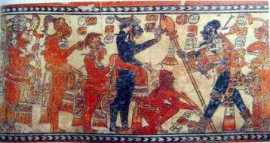  Take photos of your work and email them to school. Can you make your own Mayan mural depicting a battle or public event? | Topic  Our new topic is ‘Mysterious Mayans’.  Research Mayan gods and design your own god. Mayan carvings and drawings always show a side profile – make sure you do this too.  Research the Mayan number system and compare it to that of our own.  Complete information booklets on the geographical location of the Mayans and how this impacted on what they ate.  Draw your own map to show where the Mayan people were from.  Can you find out about Mayan rituals and why they performed them? How could you present this information?  When did the first explorers find evidence of the Mayan civilization? How did they record what they found? What did the find?  Can you create a tourist information sheet about Mayan life and the best places to visit?  Mayans were famous for their use of chocolate – can you design and make your own hot chocolate?  Look at Mayan writing and use of glyphs, can you create your own message using a Mayan code?  http://www.ancientscripts.com/maya.html | PE  Where possible please try to spend some time in your gardens playing, running, kicking and throwing balls.  Set yourself challenges and targets if you have your own equipment. Basket or netball goals in a row, how many times can you keep a football in the air with only your feet? How many times can you hit a set of cricket stumps? How many volleys against a wall can you make with a tennis racket?  Make up a new game using equipment from home.  Can you make a circuit training session and repeat daily to try and beat your scores?  If sensible try to take a short walk in a quiet area for about 30mins every other day.
Science  Animals including humans  Look at images of the skeleton, label bones in the body.  Try and find out the names for different types of bones and where they can be found.  What are the different types of joints in the body?  What are the main functions of the skeleton?  Explain and draw diagrams for how each type of joint works.  What is the circulatory system and how does it work?  What is the respiratory system and how does it work?  Light  How does light travel?  How can we see the different colours light is made up of?  What experiment could you perform to see this?  How does light enable us to see? Can you draw a diagram to show this?  What are primary sources of light? What are secondary sources of light?  How are shadows made and why do they change throughout the day? Investigate with a stick stuck in the ground outside in your garden if you have one. Don’t forget to take down your findings.  Make shadow puppets and put on your own show. | ICT  If you have access to a computer and/or the internet try to create a fact sheet, PowerPoint or database linked to an area of interest in your topic.  If possible, log in to code and complete the tasks at home. |  | Music  Find out the type of instruments and music the Mayan people may have played and listened to. Have a go at making your own Mayan instrument.  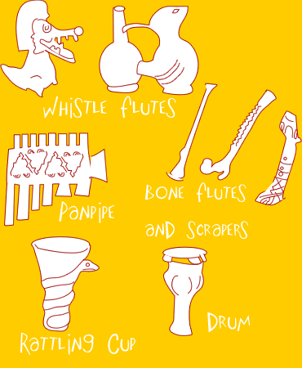  https://www.youtube.com/watch?v=cWjOaZFXo3s

