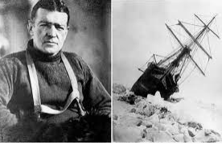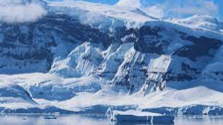**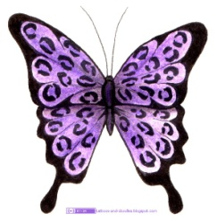Butterfly Class: Spring (1) 2022**

***Creative Curriculum Topic: To the ends of the Earth***

|  |  |  |  |
| --- | --- | --- | --- |
| **Literacy**  C:\Users\Riley.S\AppData\Local\Microsoft\Windows\Temporary Internet Files\Content.IE5\UHWWETHA\MP900422236[1].jpgAs Readers, we will be continuing our Read Write Inc Phonics programme. Children will be applying their phonic knowledge (speed sounds and Fred talk) to decode words. As writers, we will continue to look at sentence structure and punctuation. We will use this knowledge to write a diary and to write an adventure story. | **C:\Users\Riley.S\AppData\Local\Microsoft\Windows\Temporary Internet Files\Content.IE5\E7NMBIK7\MC900286276[1].wmfNumeracy**  As mathematicians, we will continue to work through addition and subtraction We will also look at 2D and 3D shapes (names and properties), and height and length. Towards the end of this term, we will be investigating place value to 50. The children will continue to apply their number skills by completing reasoning problems and Red Pen questions. | **C:\Program Files\Microsoft Office\MEDIA\CAGCAT10\j0305257.wmfScience**  As scientists, we are exploring the topic ‘Everyday materials’. We will identify and name a variety of everyday materials, including wood, plastic, glass, metal, water, and rock.  We will also describe the simple physical properties of a variety of everyday materials. | **Computing**  **C:\Program Files\Microsoft Office\MEDIA\CAGCAT10\j0205582.wmf**As computer users, we will be introducing learners to early programming concepts. The children will be grouping data using simple programmes. We will also be focussing on how to stay safe online. We will look at how we can use the internet safely. |
| **C:\Users\Riley.S\AppData\Local\Microsoft\Windows\Temporary Internet Files\Content.IE5\E7NMBIK7\MC900334196[1].wmfHistory**  As a historian; we will be looking at key events in the life of Ernest Shackleton. We will create a timeline of his expeditions to Antarctica. | **C:\Users\Riley.S\AppData\Local\Microsoft\Windows\Temporary Internet Files\Content.IE5\T54E8BE6\MP910216311[1].pngGeography**  As a geographer; we will be locating and naming the continents and oceans of the world. We will look at the human and physical geography of Antarctica. | **C:\Users\Riley.S\AppData\Local\Microsoft\Windows\Temporary Internet Files\Content.IE5\0QU0TVRJ\MC900441754[1].pngArt**  This half term we will be focussing on the artist Kiffen Williams. We will be drawing Winter landscapes using watercolours and chalk. We will also be looking at photographer Frank Hurley. | **D&T**  **C:\Users\Riley.S\AppData\Local\Microsoft\Windows\Temporary Internet Files\Content.IE5\UHWWETHA\MC900251659[1].wmf**As a designer, we will be designing and making a sledge. The children will be looking at how different materials affect how well the sledge moves over ice (friction). |
| **C:\Users\Riley.S\AppData\Local\Microsoft\Windows\Temporary Internet Files\Content.IE5\0QU0TVRJ\MC900432654[1].pngMusic**  As a musician: Through fairy tales, children are introduced to the concept of timbre; learning that different sounds can represent characters and key moments in a story. | **C:\Users\Riley.S\AppData\Local\Microsoft\Windows\Temporary Internet Files\Content.IE5\UHWWETHA\MP900424372[1].jpgPE**  In PE the focus will be on gymnastics. The children will use simple gymnastics actions and shapes. They will learn how to carry basic equipment. At the end of the unit the children will be able to link actions together. | **C:\Users\Riley.S\AppData\Local\Microsoft\Windows\Temporary Internet Files\Content.IE5\T54E8BE6\MC900048128[1].wmfRE**  As a theologist: we will be using the key question: Who is a Christian and what do they believe? We will do this by looking at key stories from the Bible, including Jonah and the Whale. We will also investigate Christian places of worship. | **C:\Users\Riley.S\AppData\Local\Microsoft\Windows\Temporary Internet Files\Content.IE5\T54E8BE6\MC900433862[1].pngPSHE**  As speakers, we will be looking at ‘Dreams and Goals’ (JIGSAW scheme of work). This involves emotional well-being and will allow the children to positively embrace the differences between people. |