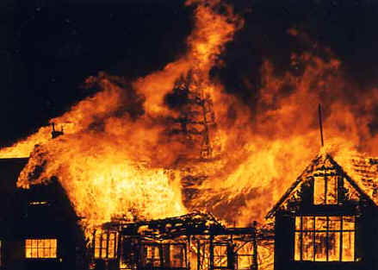**Year 2 Spring 2019**

***Creative Curriculum Topic: Great Fire Of London***

|  |  |  |  |
| --- | --- | --- | --- |
| **Literacy**  C:\Users\Riley.S\AppData\Local\Microsoft\Windows\Temporary Internet Files\Content.IE5\UHWWETHA\MP900422236[1].jpgAs writers, we will look at stories written by Anne Fine. The children will compare stories and use their skills to sequence and write their own adventure story. For Non-Fiction we will be looking at The Great Fire of London and creating recounts, diary entries and an explanation text. The class will also read and write poems with structure. | **C:\Users\Riley.S\AppData\Local\Microsoft\Windows\Temporary Internet Files\Content.IE5\E7NMBIK7\MC900286276[1].wmfNumeracy**  As mathematicians, we will be looking at place value, estimating, comparing numbers, addition, subtraction, multiplication, division, shape, length and money. The children will also apply their number skills through completing word number problems. | **C:\Program Files\Microsoft Office\MEDIA\CAGCAT10\j0305257.wmfScience**  As scientists, we are exploring the topic Light and materials. The children will learn how to ask simple scientific questions and identify sources of light. The children will perform simple scientific tests and use observations and ideas to suggest answers to questions related to light and materials. | **Computing**  **C:\Program Files\Microsoft Office\MEDIA\CAGCAT10\j0205582.wmf**As computer users, we will be exploring the topic ‘We are Astronauts’. The children will understand and learn how to create an algorithm. They will convert simple algorithms to programs and understand how these make games programs work. The children will also be completing work on Code.org. |
| **C:\Users\Riley.S\AppData\Local\Microsoft\Windows\Temporary Internet Files\Content.IE5\E7NMBIK7\MC900334196[1].wmfHistory**  As a historian, we will look at the topic ‘Great Fire of London’. The children will compare and contrast how homes were a long time ago and ask and answer questions about the events that happened in the past. | **C:\Users\Riley.S\AppData\Local\Microsoft\Windows\Temporary Internet Files\Content.IE5\T54E8BE6\MP910216311[1].pngGeography**  This term the children will use their knowledge from last term to find places on maps and atlases. They will find out where London is on a map and identify characteristics of capital cities. | **C:\Users\Riley.S\AppData\Local\Microsoft\Windows\Temporary Internet Files\Content.IE5\0QU0TVRJ\MC900441754[1].pngArt**  As an artist, we will create cityscapes in the style of Lowry. The children will show different tones by using coloured pencils and use a combination of materials that are cut, torn and glued. | **D&T**  **C:\Users\Riley.S\AppData\Local\Microsoft\Windows\Temporary Internet Files\Content.IE5\UHWWETHA\MC900251659[1].wmf**As a designer, the children will design and create a street of houses. They will cut materials safely using tools provided and demonstrate a range of cutting techniques such as tearing, cutting and folding. |
| **C:\Users\Riley.S\AppData\Local\Microsoft\Windows\Temporary Internet Files\Content.IE5\0QU0TVRJ\MC900432654[1].pngMusic**  As a musician, the children will develop their ability to recognise different ways sounds are made and changed and to name, and know how to play, a variety of classroom instruments. | **C:\Users\Riley.S\AppData\Local\Microsoft\Windows\Temporary Internet Files\Content.IE5\UHWWETHA\MP900424372[1].jpgPE**  This term in PE the children will be taking part in a dance unit related to our topic ‘The Great Fire of London’. They will also take part in a Games unit looking at being part of a team and developing ball skills. | **C:\Users\Riley.S\AppData\Local\Microsoft\Windows\Temporary Internet Files\Content.IE5\T54E8BE6\MC900048128[1].wmfRE**  As a theologist, we will be looking at the theme ‘Who is Jewish and what do they believe?’ The children will listen to different stories and explore how and why we celebrate special and sacred times? | **C:\Users\Riley.S\AppData\Local\Microsoft\Windows\Temporary Internet Files\Content.IE5\T54E8BE6\MC900433862[1].pngPSHE**  As speakers, we will be looking at ‘Drugs and their Uses’. This involves the children learning that medicines and household goods can be dangerous and should be stored away carefully. The children will also understand that all medicines are drugs but not all drugs are medicines. |

Mrs Critchlow and Mrs Blower 2019