ARLEY PRIMARY SCHOOL

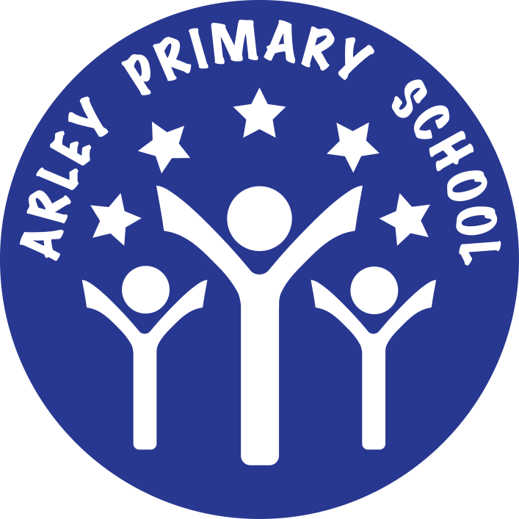

ACCESSIBILITY POLICY AND PLAN

Ratified by FGB:

Chair of Governing Body:

Date for Review:

This Accessibility Policy and Plan are drawn up in compliance with current legislation and requirements as specified in Schedule 10, relating to Disability, of the Equality Act 2010. School Governors are accountable for ensuring the implementation, review and reporting on progress of the Accessibility Plan over a prescribed period.

- We are committed to providing an accessible environment which values and includes all pupils, staff, parents and visitors regardless of their education, physical, sensory, social, spiritual, emotional and cultural needs. We are committed to challenging negative attitudes about disability and accessibility and to developing a culture of awareness, tolerance and inclusion.

- Arley Primary School plans, over time, to ensure the accessibility of provision for all pupils, staff and visitors to the school.

- An Accessibility Plan will be drawn up to cover a three-year period. The plan will be updated annually.

- The Accessibility Plan will contain relevant actions to:

  - Improve access to the physical environment of the school, adding specialist facilities as necessary. This covers reasonable adjustments to the physical environment of the school and physical aids to access education.

  - Increase access to the curriculum for pupils with a disability, expanding and making reasonable adjustments to the curriculum as necessary to ensure that pupils with a disability are as, equally, prepared for life as are the able-bodied pupils; (If a school fails to do this they are in breach of the DDA). This covers teaching and learning and the wider curriculum of the school such as participation in after-school clubs, leisure and cultural activities or school visits. It also covers the provision of specialist aids and equipment, which may assist these pupils in accessing the curriculum.

  - Improve and make reasonable adjustments to the delivery of written information to pupils, staff, parents and visitors with disabilities. Examples might include hand-outs, timetables, textbooks and information about the school and school events. The information should be made available in various preferred formats within a reasonable time frame.

- The Action Plan for physical accessibility relates to the Access Audit of the School, which is undertaken regularly. It may not be feasible to undertake some of the works during the life of this first Accessibility Plan and therefore some items will roll forward into subsequent plans. The audit will need to be revisited prior to the end of each first three- year plan period in order to inform the development of the new Plan for the following period.

- We acknowledge that there is a need for on-going awareness raising and training for staff and governors in the matter of disability discrimination and the need to inform attitudes on this matter.

Arley Primary School Accessibility Plan 2017-2020

Improving the Physical Access at Arley primary School

If a pupil with a disability is given a place at Arley Primary School any adaptation will be made to accommodate pupil need.

When Arley Primary School was built in 2013, it was fully compliant with all building standards, including access for

individuals with a disability:

- The building is all on one level and is totally flat.

- There are 2 disabled toilets, one of which contains a shower.

- Doorways are wide enough for an adult wheelchair to pass through.

- Specifically designated parking bay, with a dipped curb.

Arley Primary School Accessibility Plan 2017-2020

Improving the Curriculum Access at Arley Primary School

Target | Strategy | Outcome | Responsi- bility | Time- frame | Achievement
Audit of pupil needs and staff training to meet those needs. | Review the specific needs for pupils living with a disability, in terms of basic daily living skills, relationships and future aspirations. | Teachers are aware of the relevant issues and can ensure that this group has equality of access to life- preparation learning. The use of other professional partners has been made available. | All staff | Ongoing | All school activities are accessible to all disabled pupils
All out-of-school activities are planned to ensure, where reasonable, the participation of the whole range of pupils | Review all out-of-school provision to ensure compliance with legislation | All out-of-school activities will be conducted in an inclusive environment with providers that comply with all current and future legislative requirements | DHT | Ongoing | All out of school activities are accessible to all disabled pupils
Classrooms are organised to promote the participation and independence of all pupils | Review and implement a preferred layout of furniture and equipment to support the learning process in individual class bases | Lessons start on time without the need to make adjustments to accommodate the needs of individual pupils | Teaching Staff | Start of each year | Increase in access to the National Curriculum
Training for Awareness Raising of Disability Issues | Provide training for governors, staff, pupils and parents. Discuss perception of issues with staff to determine the current status of school | Whole school community aware of issues relating to Access | SLT | Ongoing | Community will benefit by a more inclusive school and social environment
Training for teachers on  differentiating the curriculum | Review the specific  needs for pupils living with a disability, in terms of basic daily living skills, relationships and future aspirations. | Teachers are aware of the relevant  issues and can ensure that this group has equality of access to life- preparation learning. The use of other professional partners has been made available. | SENDco | When Required | Increase in access to  the National Curriculum
Increased access to the curriculum for pupils with a disability | The curriculum is reviewed to ensure that it meets the needs of all pupils  Resources tailored to the needs of pupils who require support to access the curriculum. | All pupils, regardless of disability are able to access the curriculum as fully as possible. | SENDco | On going | Pupils able to access more of the curriculum effectively

Arley Primary School Accessibility Plan 2017-2020

Improving the Delivery of Written Information at Arley Primary School

TARGET | STRATEGY | OUTCOME | RESPONSIBILITY | TIME FRAME | ACHIEVEMENT
Availability of written material in alternative formats when specifically requested. | The school will make itself aware of the services available for converting written information into alternative formats. | The school will be able to provide written information in different formats when requested for individual purposes | Office/SLT/ Inclusion Leader | Ongoing | Delivery of information to disabled pupils improved
Make available school brochures, school newsletters and other information for parents in alternative formats when specifically requested. | Review all current school publications and promote the availability in different formats when specifically requested | All school information available for all who request it. | Office/SLT/ Inclusion Leader | Ongoing | Delivery of school information to parents and the local community improved
Review documentation with a view of ensuring accessibility for pupils with visual impairment | Get advice from HVSS on alternative formats and use of IT software to produce customized  materials. | All school information available for all | SENDco | As and when required. | Delivery of school information to pupils & parents with visual difficulties improved.

