The following mathematical concepts and procedures reflect the Singapore Maths approach to teaching Mathematics at Arley Primary School.

The methods and approaches are tailored to meet the expectations and objectives of the National Curriculum for England.







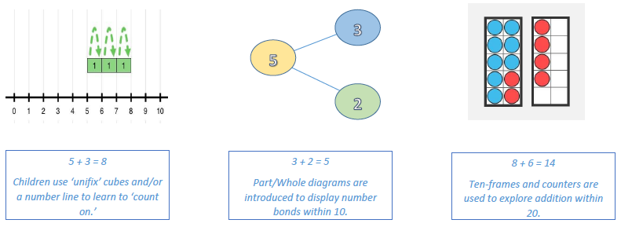Early Addition

Pupils will use a range of ‘concrete’ resources to support exploration of the mathematical concepts.

Ideas are presented to pupils in a variety of contexts, progressing from simple concepts to

addition word problems that require addition within 20.



Tens and Ones

Tens Ones

1. 3

1 2

3 5

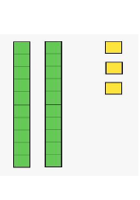Tens Ones Tens Ones Tens Ones

20 3

10 2



30 5

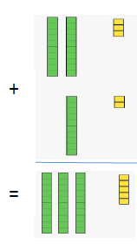





BUILDING TOWARDS COLUMN ADDITION

This exploration with Dienes provides a concrete link to column addition. This is reinforced with 2-digit addition learning opportunities spanning several lessons during Year 2.

DIENES

Children build on their use of ten-frames to explore numbers using Dienes. These help to embed an understanding of ‘tens and ones’ when looking at 2-digit numbers.

Renaming/Regrouping and further application

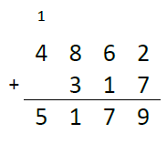

1 1 1

1. . 0 3 8

0 . 9 8 4

2 . 0 2 2

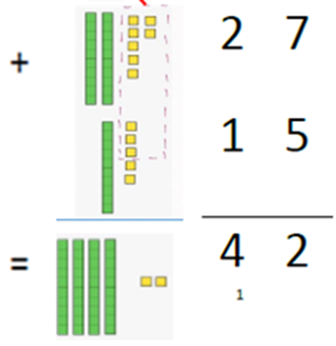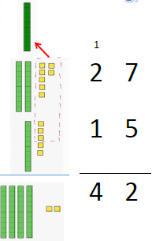







DECIMAL ADDITION

Column addition is then applied to the addition of decimal numbers in Upper Key Stage 2.

GREATER NUMBERS

As they progress through Key Stage 2, children apply column addition to larger numbers. There is an increasing amount of ‘renaming/regrouping’ across a range of values.

DIENES

Continue their exploration using Dienes, children encounter 2-digit addition that requires ‘regrouping’ or ‘renaming’ ten ones as one ten. This is then linked to the column addition method.

Early Subtraction

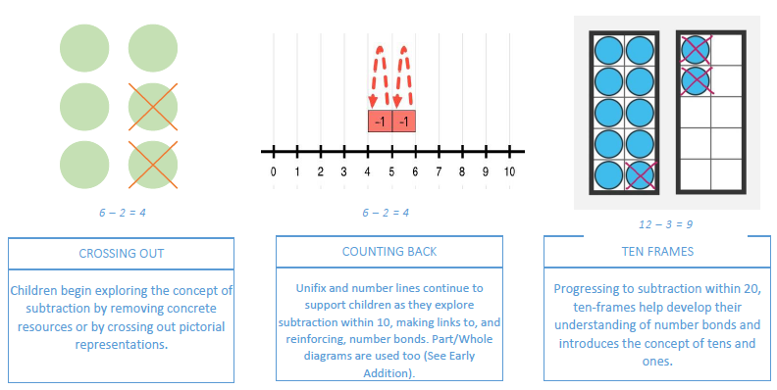

Tens and Ones

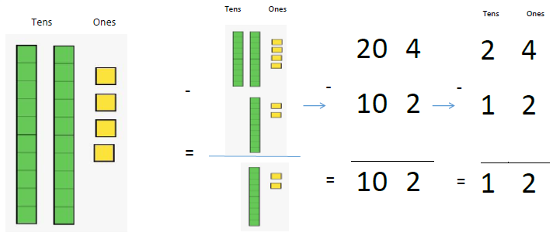

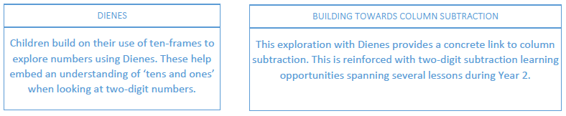

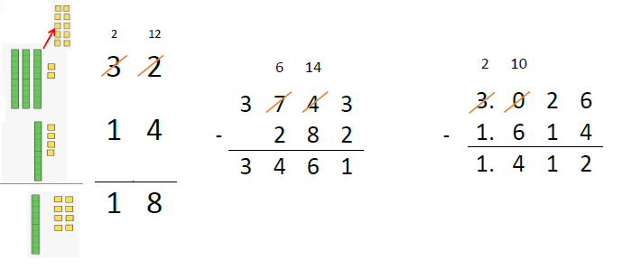Renaming/Regrouping and further application



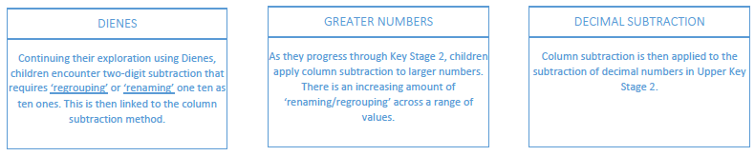

Early Multiplication

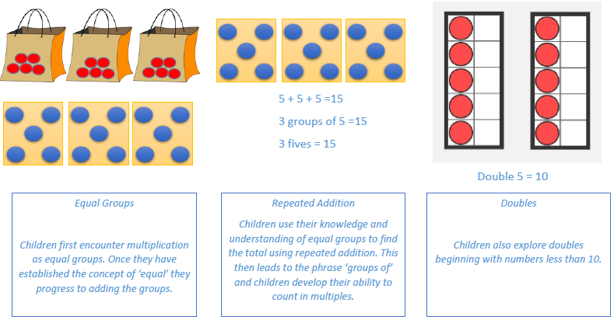

Times Tables

Concrete Pictorial Abstract

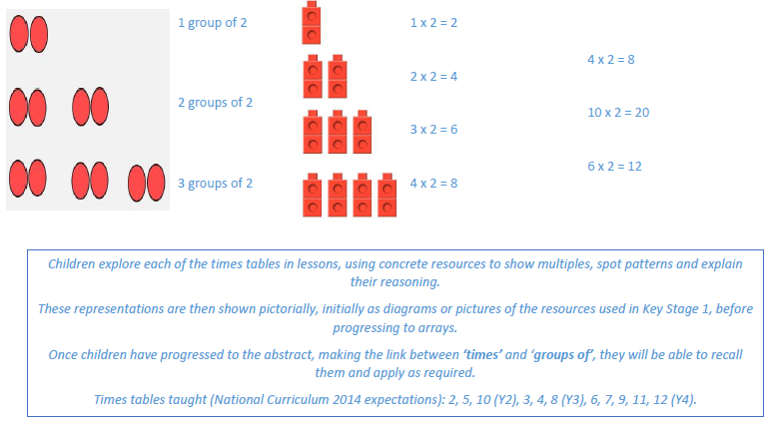

Formal Multiplication

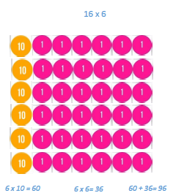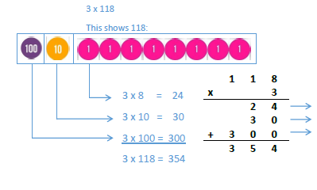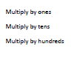

1. **1 8**

**X 3**

**3 5 4**



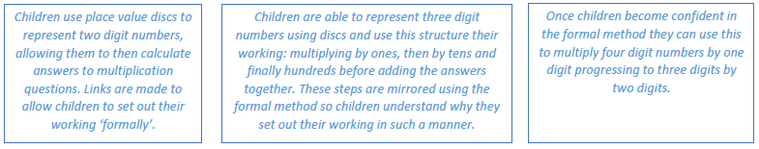

Early Division

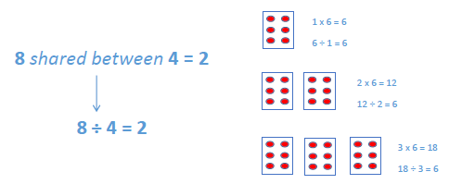

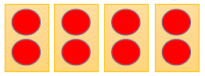

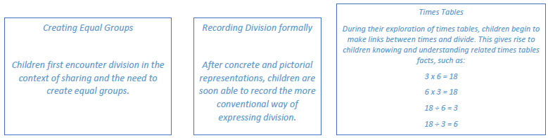

Formal Division

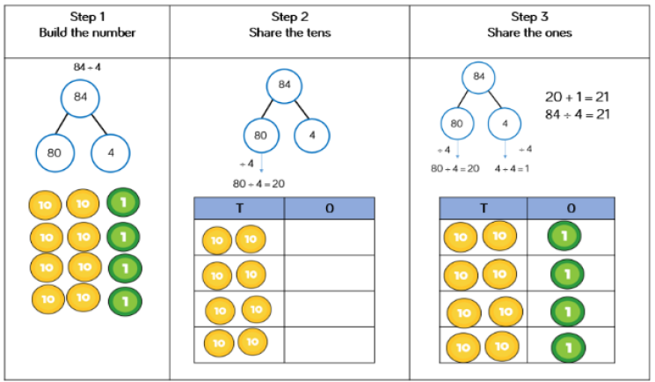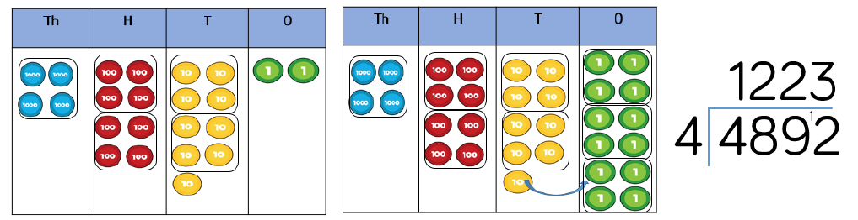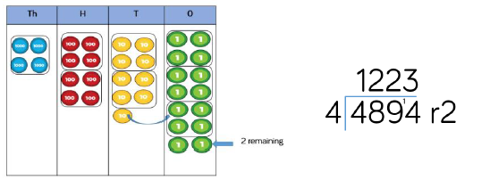

**The use of place value discs help children partition and share numbers into the desired number of groups. These steps are then linked to the convention of the short formal method.**

**Children progress to dividing 3 and 4 digit numbers and also numbers that give rise to a remainder.**

**Pupils will eventually be expected to give remainders in the form of a decimal depending on the context of the question.**