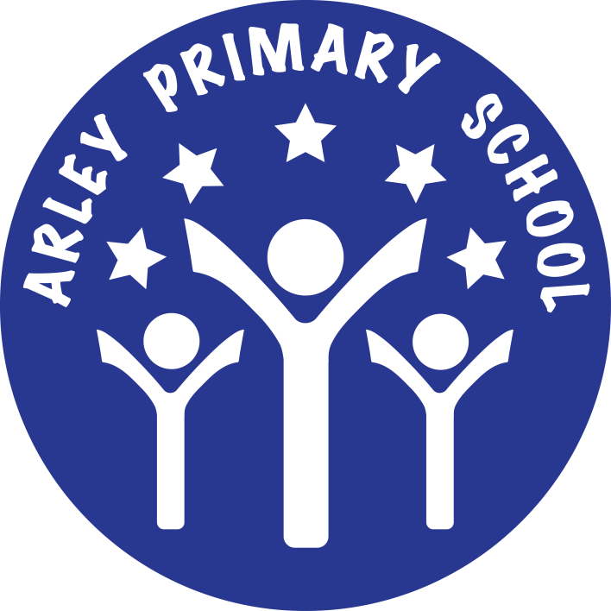

**Woodpecker Class**

**Summer Term**

**Newsletter**

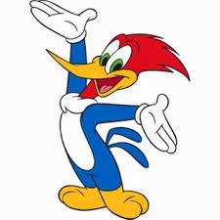**2019**

Dear Parents, this is our termly newsletter designed to keep you up to date with what’s going on during the Summer Term.

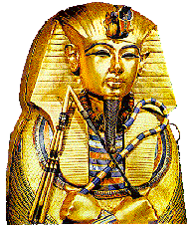This term we have 2 mini-projects. This half-term’s project will be ‘Eureka! – Inventions and Discoveries’ which is a science and technology based project looking at some of the inventions and discoveries that have changed the way we live and the people associated with them. Next half-term our project will be ‘Walk like an Egyptian’ a history based project looking at the Ancient Egyptian civilisation.

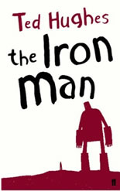Our literacy work this term will include: work themed around the class novel ‘The Iron Man’ as well as some biographical writing on inventors and scientists. We will also be using persuasive language to sell a new invention. Finally we will be debating whether Howard Carter was right to remove artefacts from Tutenkahmun’s pyramid.

In Maths we have looked at fractions and decimals and will be looking at money, time and shape later in the term.

Our RE work will be looking at the questions: Why do some people think life is a journey?, What does it mean to be a Christian in Britain today? And What does it mean to be a Hindu in Britain today?

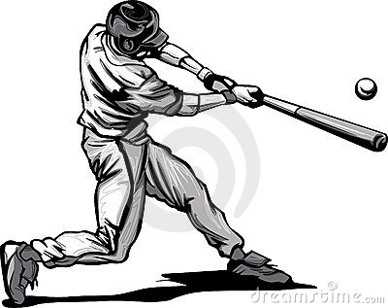 In technology we will be attempting to build toys and inventions with moving parts. Thanks for saving your ‘junk modelling’ boxes, tubes and egg boxes! **We still need lots more cardboard tubes from kitchen and toilet rolls please!**

PE is focussed on striking and fielding games and Outdoor Adventurous Activities.

In computing we are going to invent an interactive game.

In Science we are looking at different scientists famous for discovering and inventing things like Thomas Edison . We will also look at light and reflection.

**Other Useful Information:**

**PE days are:**

C:\Users\elmer.j.WARWICK.000\AppData\Local\Microsoft\Windows\Temporary Internet Files\Content.IE5\3E2RAUFI\MC900212975[1].wmfTuesdays and Thursdays. I am really pleased to see **nearly** all children wearing the correct PE kit of black/navy shorts, plain white t-shirt and black pumps, however some pupils dont have a white t-shirt or suitable footwear in school for PE. Thank you for ensuring they have the correct kit in school.

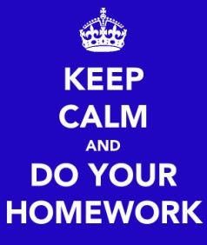

**Homework days are:**

**Monday** – Reading

**Wednesday** – Spelling practice (with a quick check on Thursday night before the big test on Friday!)

**Friday** – Times-tables practice.

If you are able to read or practise tables more often that would be great but diaries will be checked after each homework night above to see if homework has been completed. Pupils are rewarded for homework completed and signed on the correct nights.

Don’t forget the door is always open if you need to see us! Kind regards,

Mr. Elmer