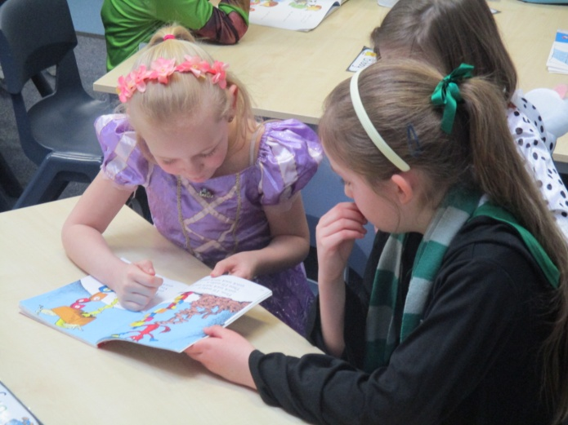
World Book Day 2019 – Year 4 children sharing a book with year 1 children.

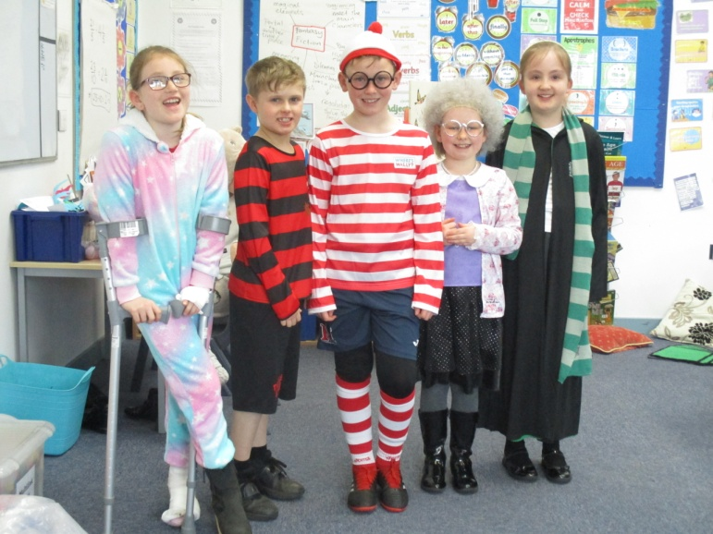
World Book Day 2019 – Some of our fantastic costumes (Year 4)
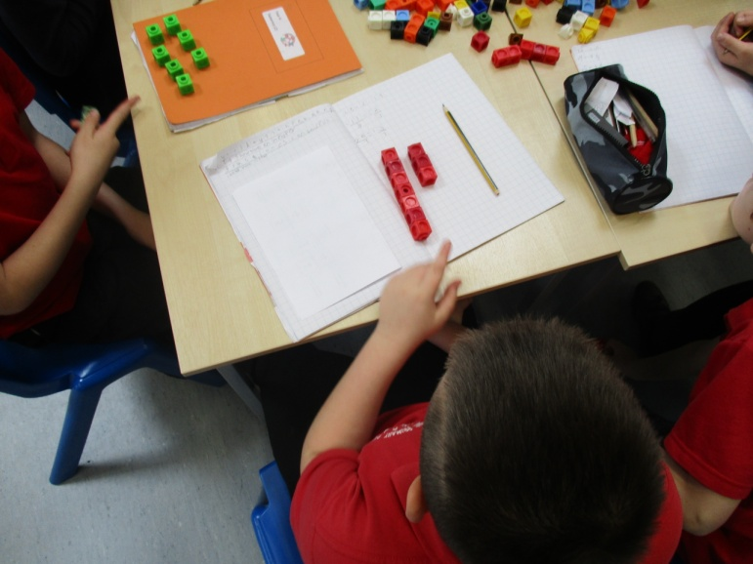
Practical Maths in Year 4: Working out fractions greater than 1 whole.
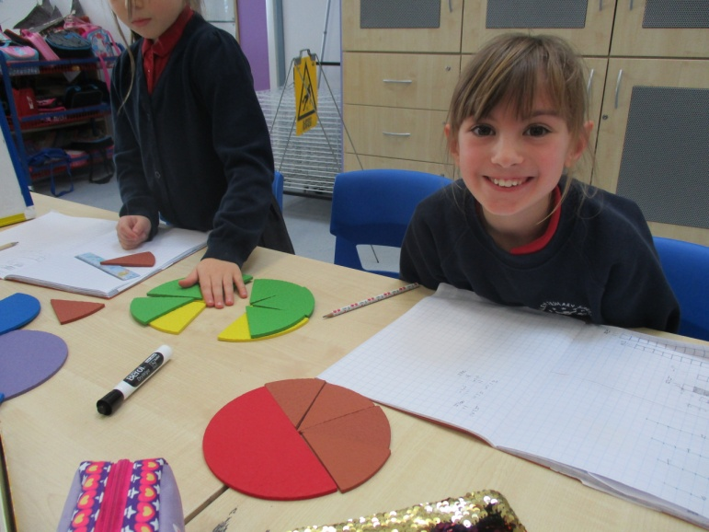
Year 4 working out equivalent fractions.
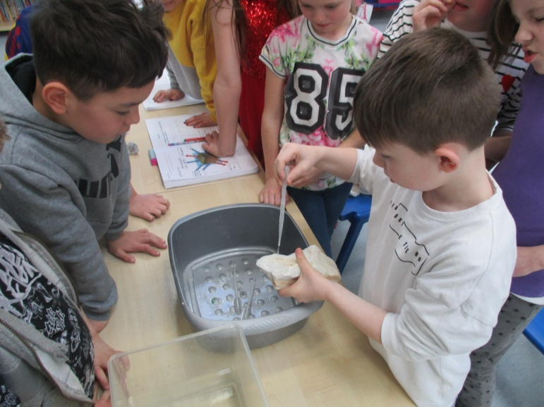
Testing properties of rocks – Year 4 Science

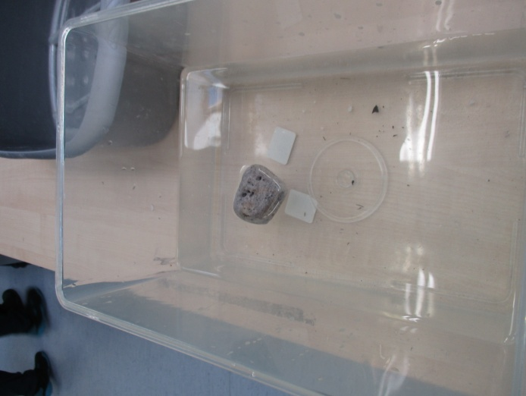
It floats!!

